CS 1632 – DELIVERABLE 3: Automated System Testing of a Web Application

Matt Stropkey

https://github.com/mas682/1632Deliverable3

Creating the program itself was not all that difficult. I have actually never used HTML before but it was pretty easy to figure out. After looking through the Sinatra examples it was easy to write my code. The main issues I had were with katalon itself. I found it challenging to figure out how to test certain values, such as making sure “ERROR” was displayed using a h1 header. There were also so many different asserts that it was somewhat overwhelming to choose which one would be best to use for what, such as assert value, assert text, or assert table. I also struggled a little with being able to tell which address the program was currently at, specifically for making sure the return to home links did in fact lead to the home page. I eventually figured out to use assert location but the API for many of these asserts was at times confusing. Other than issues with katalon, I thought the project was very useful and a good overall learning experience.

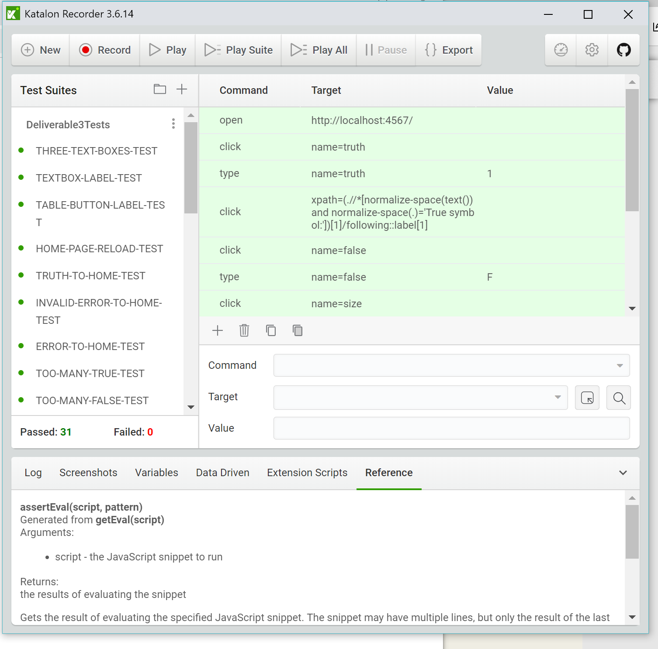

**REQUIREMENT1:** THREE-TEXT-BOXES-TEST, TEXTBOX-LAVEL-TEST, TABLE-BUTTON-LABEL-TEST

**REQUIREMENT2:** HOME-PAGE-RELOAD-TEST, TRUTH-TO-HOME-TEST, INVALID-ERROR-TO-HOME-TEST, ERROR-TO-HOME-TEST,

**REQUIREMENT3:** TOO-MANY-TRUE-TEST, TOO-MANY-FALSE-TEST, INVALID-SIZE-TEST, INVALID-SIZE-CHAR-TEST,INVALID-SIZE-ONE-TEST

**REQUIREMENT4:** VALID-TRUTH-TEST, VALID-FALSE-TEST, VALID-SIZE-TEST, INVALID-TRUTH-TEST, INVALID-FALSE-TEST, SMALL-SIZE-TEST, INVALID-INPUT-SIZE-TEST, INVALID-SAME-SYM-TEST, VALID-NONALPHA-TEST

**REQUIREMENT5:** NUM-SYMBOL-OUTPUT-TEST, CHAR-SYMBOL-OUTPUT-TEST, BIT-DESCENT-TEST, TOP-LABEL-TEST

**REQUIREMENT6:** AND-RESULT-TEST, OR-RESULT-TEST, NAND-RESULT-TEST, NOR-RESULT-TEST

**REQUIREMENT7:** NO-DATA-TEST

**REQUIREMENT8:** UNSPECIFIED-URL-TEST